4.52: a) mass of one link

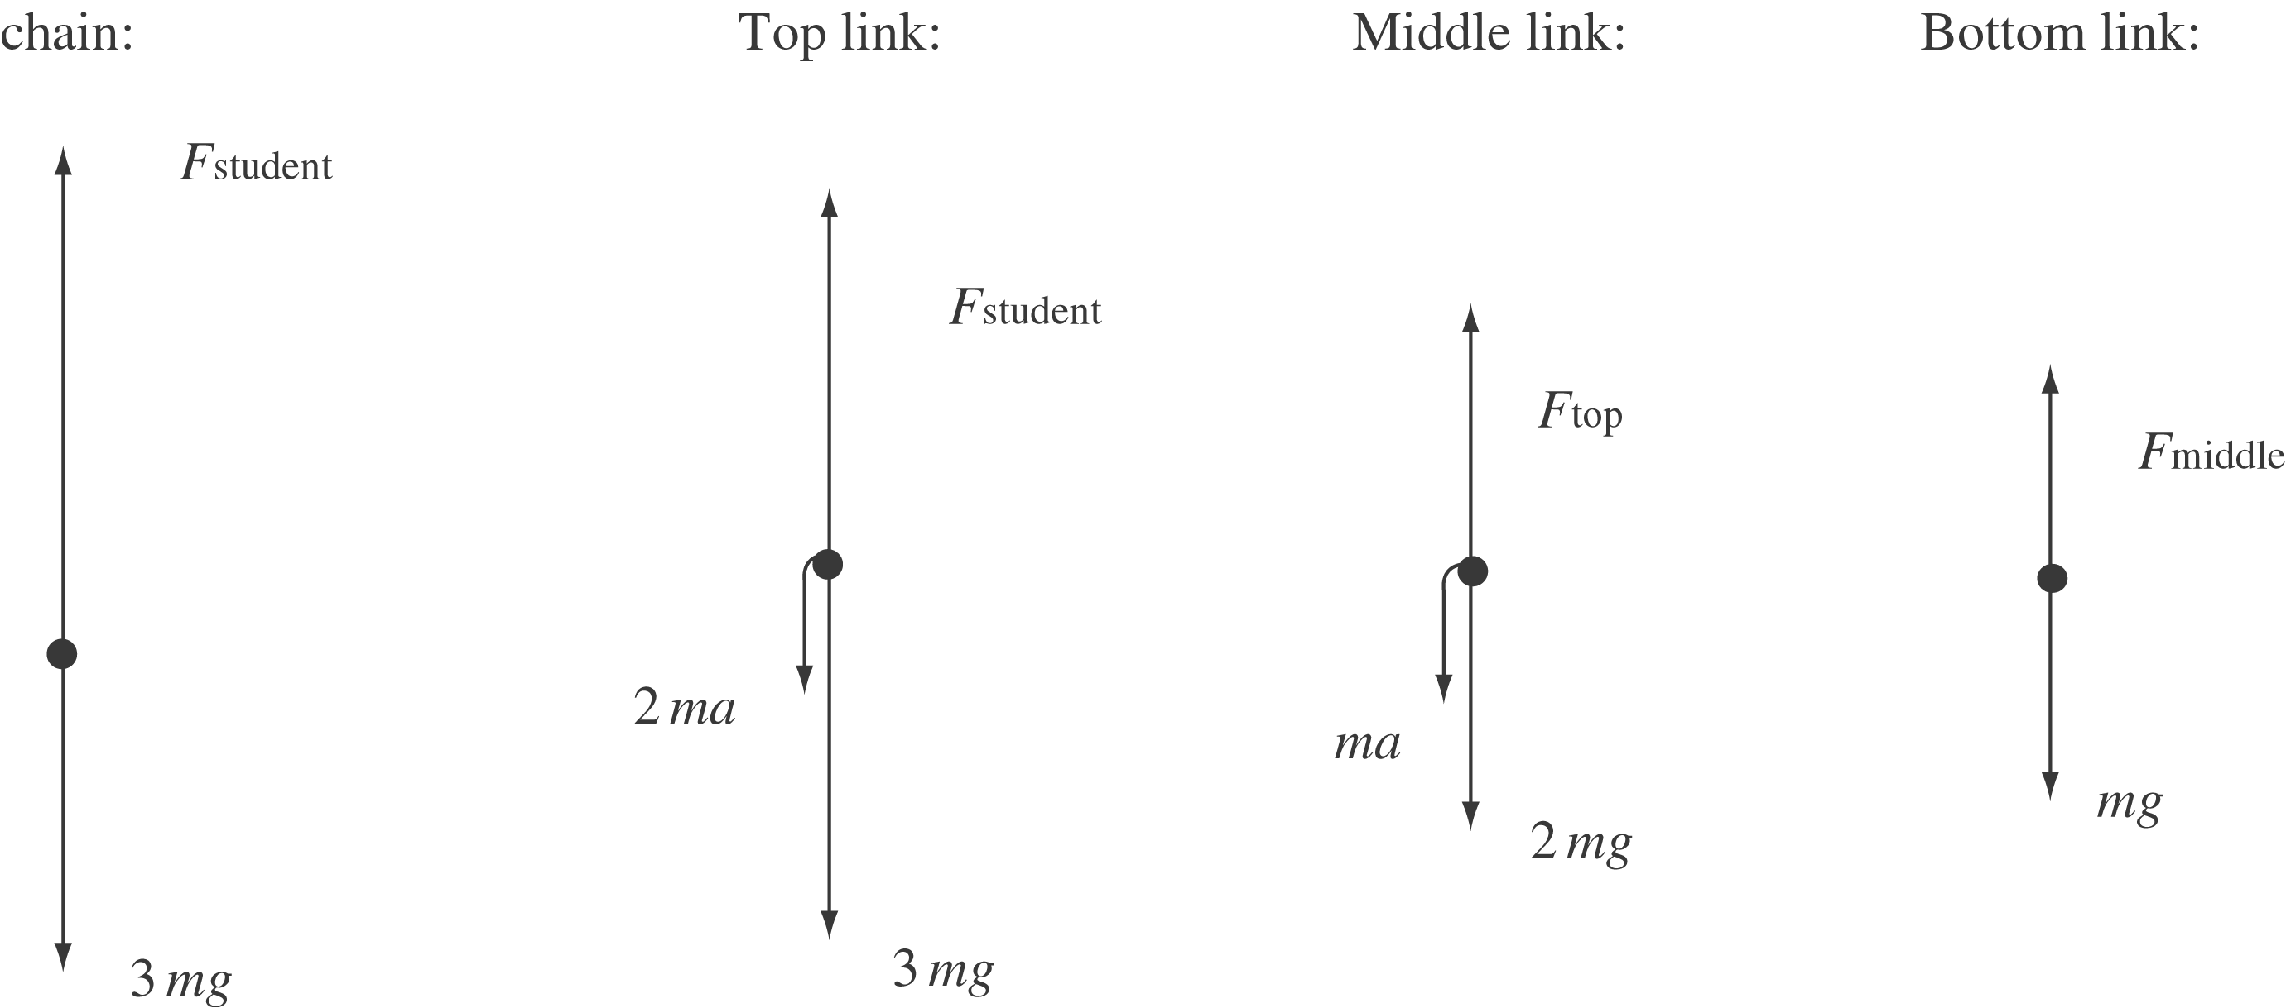

The downward forces of magnitude 2ma and ma for the top and middle links are the reaction forces to the upward force needed to accelerate the links below.
b) (i) The weight of each link is . Using the free-body diagram for the whole chain:
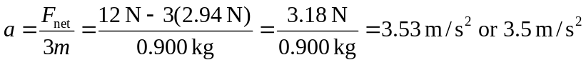
(ii) The second link also accelerates at 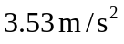, so:

